Access to Ethical & Sustainable Supply DPS to drive Social Value

Dynamic Purchasing System Requirements

1. Introduction 2
2. What is a DPS? 2
3. Purpose of the DPS 3
4. The Opportunity 4
5. DPS Call-Off 5
6. DPS Management and Support 6

Introduction

  - Bishop Wilkinson Catholic Education Trust (BWCET) are seeking to establish a Dynamic Purchasing System (DPS) for the provision of commonly used goods and services from a wide range of suppliers to create an ethical and sustainable supply chain to drive social value outcomes.

  - Education Commercial Services (ECS) is the trading name of Bishop Wilkinson Commercial Services Ltd, a wholly owned subsidiary of Bishop Wilkinson Catholic Education Trust (BWCET) who provide specialist procurement services to the education sector.

  - ECS is delivered by Value Match Services Limited (VMS) who manages all customers, commercial and procurement activity on behalf of ECS and their customer base. Value Match Services also provide managed procurement solutions across the public and private sector.

  - All further competitions under the DPS Agreement, will be managed by ECS on the Customer’s behalf via the Cimple portal. Customers will have the option to build the further competition themselves or with the support of ECS.

  - Education Commercial Services (ECS) is focused on providing high quality commercial support to the education sector with a specific focus on supporting the North East region. Our goal is to ensure we use the most effective route to market for the customer, taking into account their individual objectives whilst identifying savings, ethical and sustainable benefits.

  - The DPS will be available and open to the full Public Sector to access an ethical and sustainable supply chain for commonly used goods and services across all regions within the United Kingdom (UK). Please use the below link to see all eligible Contracting Authorities within the UK who are able to access this DPS.

https://www.legislation.gov.uk/uksi/2021/872/schedule/1/made#f00008

What is a DPS?

  - A DPS is a public sector sourcing tool for common goods and services under
regulation 34 (Dynamic Purchasing Systems) of the PCR 2015. You can apply to join at any point throughout the duration of the DPS. Its aim is to eliminate
unnecessary activity up front for suppliers, allowing for a more effective procurement process. The DPS must be run as a completely
electronic process therefore the DPS will be managed via the Cimple portal https://app.cimple.uk/login

Purpose of the DPS

  - The DPS has been designed and set up to have a focus on ethical and sustainable practices across suppliers and their supply chain.

  - An ethical supply chain operates in a way that delivers the highest level of ethical, responsible and sustainable operations, ensuring all workers are treated equally and fairly and that environmental and social impacts are considered across the full supply chain.

  - The DPS will admit suppliers who (and including throughout their supply chain) can demonstrate best practice in an appropriate and proportionate manner to their organisation and the goods and or/services they supply, in the following areas:

- Equal opportunities and diverse approach to training, wellbeing and recruitment within the workforce
- No modern slavery within their organisation and supply chain
- Approach to ethical supply, sustainable procurement and quality and governance across their organisation and supply chain
- Environmental factors such as approach to carbon reduction, water consumption, waste management and the circular economy
- Commitment to prompt payment throughout their supply chain

  - The DPS will create the following benefits across all sectors, locations and suppliers:

- support local SMEs, charities and social enterprises by providing a platform for growth thereby supporting the local economy
- increase the creation of social value within the following themes; Covid-19 Recovery, Tackling Economic Inequality, Fighting Climate Change, Equal Opportunity and Wellbeing
- reduce impact on the environment, whether this be carbon, water, waste reduction and/or circular economy principles
- encourage 10-day payment terms for suppliers and subcontractors to support local businesses
- create supplier awareness and encourage suppliers to embed new working practices in relation to ethical supply, sustainability, community and employee support throughout the supply chain

  - The DPS will encourage the use of the published Social Value Model in all further competitions to create social value benefits using the following themes:

    - Theme 1: Covid-19 Recovery
    - Theme 2: Tackling Economic Inequality
    - Theme 3: Fighting Climate Change
    - Theme 4: Equal Opportunity
    - Theme 5: Wellbeing

Please follow the link to find out further information on the Social Value Model
https://assets.publishing.service.gov.uk/government/uploads/system/uploads/attachment_data/file/940826/Social-Value-Model-Edn-1.1-3-Dec-20.pdf

  - Benefits of using the DPS as a procurement route:

- Simple, quick process – access to a range of ethical and sustainable suppliers of all sizes seeking opportunities to provide goods and/ or services to the public sector
- Flexible – new suppliers can apply to join the DPS at any point
- Automated electronic process
- Choice – wide range of goods and/or services available and access to the full public sector
- Filtering of suppliers –enabling further competitions to be streamlined and targeted to capable suppliers
- Dynamic – customers can create bespoke specifications, competitions, and contracts
- Supports local – able to access local and regional suppliers
- Savings – drives saving through the further competition process
- Efficiencies – reduces customer and supplier costs and process cycle time
- Procurement support from ECS from specification development, managing the tender process and contract management support.

The Opportunity

  - The Ethical & Sustainable Supply DPS will provide eligible Contracting Authorities with the opportunity to procure commonly used goods and/or services from a wide range of ethical and sustainable suppliers.

  - Customers can shortlist appointed suppliers by using the category filters and invite them to further competition

  - The three (3) categories compromise of:

    - Service Category – CPV codes
    - Geographical Location – NUTS codes
    - Additional Capabilities – Security Clearance, Value Threshold, Cyber Essentials

  - Please find the Service Filter Categories including within Appendix 1 – DPSQ for Ethical & Sustainable Supply

  - The intended contract duration of the Ethical & Sustainable Supply DPS is for six years (72 months) from 9th May 2022 to 8th May 2028.

  - Customers may enter into a contract with a supplier for a contract period determined by the customer. The contract period will be included in the further competition documentation and may exceed the duration of the Ethical & Sustainable Supply Chain DPS Agreement

  - A customer may elect to extend the Contract initial period. However, the Contract period, including any extension period, under procurement best practice guidance, should not take the contract period beyond sixty (60) months in total.

  - The flexibility of the contracting period allows you to determine appropriate contracting timelines required in order that the supplier can meet your needs for large and complex projects.

  - In the event that the Ethical & Sustainable Supply Chain DPS is terminated, ECS shall give the Customer no less than three (3) months written notice. Individual projects may continue until the contracted end date with the individual Supplier following DPS termination.

DPS Call-Off

  - All customers will need to sign the Customer Access Agreement in order to run further competitions under the DPS.

  - Completed Customer Access Agreement(s) should be submitted to ecsenquiries@ecservices.org.uk

  - Customers will have the option to build and manage the further competition procedure themselves or with the support of ECS via the Cimple portal (https://app.cimple.uk/login)

  - The further competition template (Appendix 5) is available for you to use to build your competition, however you are able to use a template of your choice

  - Your further competition documents must include the full and exact requirements and specification required including but not limited to:

    - Specification
    - Delivery Instructions
    - Timescales
    - Evaluation & Award Criteria including Social Value
    - Key Performance Indicators (KPIs)

  - Any Special Terms and Conditions that apply to your further competition should be included within the competition documents

  - The minimum timescale for return of tenders under the further competition procedure is ten (10) days.

DPS Management and Support

  - ECS are committed to the successful delivery of the Ethical & Sustainable Supply DPS and subsequently committed to working with all Customers to support them to achieve their objectives when running a further competition via the DPS.

  - ECS will manage the further competition process on your behalf via the Cimple portal (https://app.cimple.uk/login) this would include review of your further competition documents and management of clarifications and tender responses via the portal.

  - Please find below standard workflow for management of further competitions via the DPS
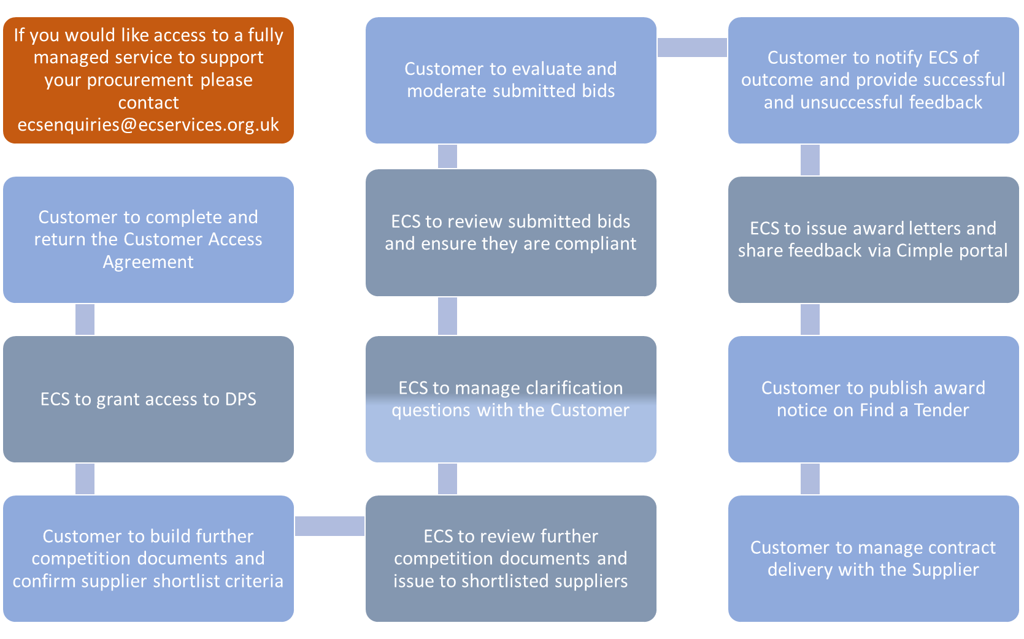

  - If you need specific procurement and commercial advice beyond the management of the further competition via the portal, ECS would be happy to explore how we could further support you.

  - ECS offer a wide range of procurement activity such as stakeholder engagement, market insight and engagement, specification development through to evaluation training, evaluations and moderations as well as effective contract management.

  - Please contact ecsenquiries@ecservices.org.uk to discuss the options for specialist advice

